# Report for Ryan Wedge (2024-10-01 to 2024-10-31)

Average Bat Speed: 40.50

Average Rotational Acceleration: 7.44

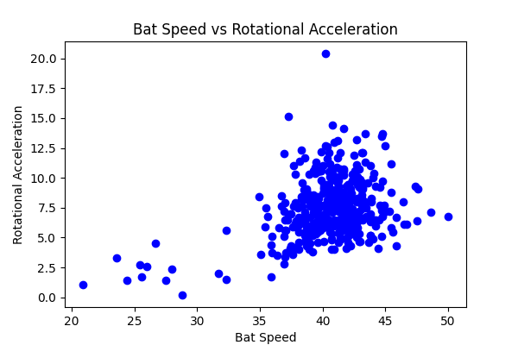

## Comments

Add comments here...